**QUANTIFERON-TB Gold Plus**

**SPECIMEN COLLECTION INSTRUCTIONS**

1. Ensure correct patient identity.
2. Print patient information labels.
3. Collect the blood and ensure **correct volume** of blood and **correct sequence**.

Ensure that the **correct volume** is drawn by checking that the level of blood in any tube falls within the **black volume indicator mark** (0.8-1.2 ml) as in Fig. 1. The tubes need to be at room temperature (not cold) before specimen collection. The tourniquet should be removed when the blood enters the tube.

 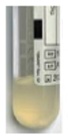

Black line =Volume indicator mark

**Blood Level must** **be within volume** **indicator mark**

1. Ensure the **correct sequence** of collection into the tubes:

1. **Control (GREY top) → TB1 (GREEN top) → TB2 (YELLOW top) → Mitogen (PURPLE top)**.
2. Post collection, shake the tubes 10 times ensuring that the entire inner surface of the tube has been coated with blood.

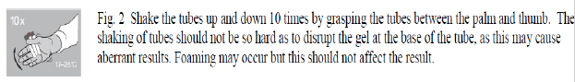

1. **Label all tubes with patient information labels**. Place tubes into a biohazard bag.
2. **Complete the request form and paste the patient information label on the request form as well and place it into the same biohazard bag as the tubes.**
3. Send the tubes and this request form to the laboratory at room temperature. There is no need to keep the tubes upright during transportation.
4. All Specimens must be received at KKH Lab **Monday- Friday by 2 pm except eve of public holidays (PH) and public holidays.**

* Note: Specimens will not be accepted on Saturdays, Sundays, eve of PH and on PH. (Instructions on filling in of Request form overleaf)

**Instructions for filling up Quantiferon Request Form**

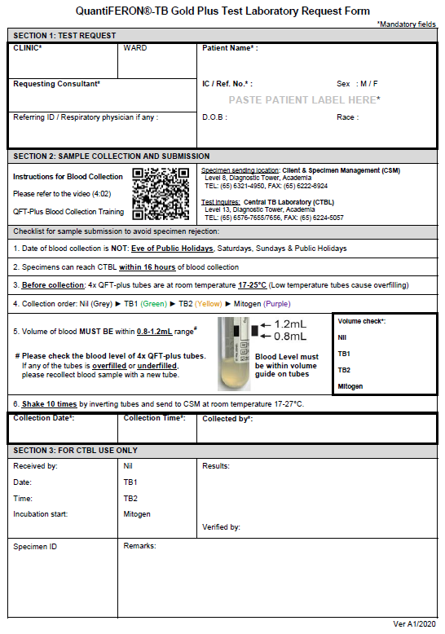

**Fill in accordingly**

**Fill in accordingly**

**Fill in accordingly**

**Fill in accordingly**

Paste patient’s OAS / SAP label

**Fill in accordingly**

**Fill in accordingly**

**Fill in accordingly**